**Emir Uzunovic**

|  |  |
| --- | --- |
| Contact: | [Related](https://codepen.io/EmirU/pens/public/) links: |
| Email: emir.uzunovic@gmail.com | <https://www.jullo.biz/> |
| Phone: +387 61 811 779 | <https://ba.linkedin.com/in/emir-uzunovic-a6638855> |
| Skype: uzunovice | <https://github.com/EmirUzunovic>  <https://sourcerer.io/emiruzunovic>  <https://www.freecodecamp.org/emiruzunovic> |

**Professional Summary**

I am a self-started front end Web Developer, seeking an opportunity to be apart of a team with a similar passion for coding. I wish to share my previously acquired skills and learn from others with a similar software background. I am able to efficiently create a web design and modify web content. I have gained knowledge through my four years of experience in analyzing customer needs and taking on the role of technical expert in contract for Software Development and Maintenance of Energy trading and risk management (ETRM) software.

**Key Skills**

* ***Web Technologies &* Libraries*:*** HTML5, CSS, JavaScript, ReactJS, Bootstrap, MaterializeCss, jQuery, Sass, ReduxJS
* ***Web Debug Tools:*** Chrome developer tools,
* ***Versioning and other tools:*** Git, GitHub, Visual Studio
* ***Other:*** Clean code. No console errors, basic understanding of Photoshop & Illustrator and optimizing images for web
* ***Interpersonal Skills:*** Developed strong customer service as well as team building skills in past positions
* ***Language:*** English, Bosnian, Croatian and Serbian

**Experience and Projects**

Project which I would like to emphasise is project management tool app, with authentication and cloud functions. It has login and signup forms connected to firebase auth service, and a data entry form connected to Firebase database. Under the hood it is using React, Redux, and Thunk for asynchronous code. Also a third-party packages to connect to Firebase and Firestore from Redux was used. Firebase Cloud Functions are responsible for fleshing out the Notification component in React app, showing any notifications from Firebase. For more details please refer to my portfolio site <https://www.jullo.biz>.

I have experience with Building websites from scratch with fluid design (not only responsive), Integrating the CMS into the sites, Testing in all major browsers/devices, have tales of horror while fixing issues in IE, figuring out solutions to unique problems.

Fore more details please refer my portfolio page https://www.jullo.biz , extract from my GitHub account is in table below: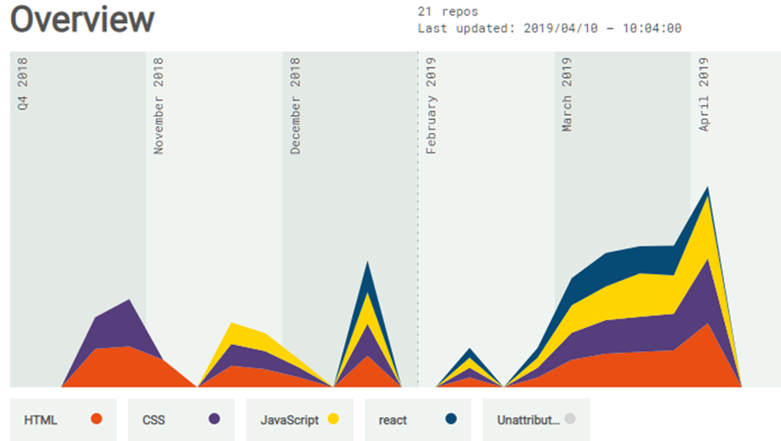

***Source: https://sourcerer.io/emiruzunovic***

**Education and training**

**Master’s Degree in Management and Organization**

University of Sarajevo, School of Economics and Business 2014-2018

**Bachelor’s Degree in Economics / Marketing, ICAS assessed**

University of Sarajevo, School of Economics and Business 2003-2008

FreeCodeCamp **Responsive Web Design** Certification (300 hours)

#### FreeCodeCamp **Javascript Algorithms And Data Structures** Certification (300 hours)

#### FreeCodeCamp **Front End Libraries** Certification (300 hours)

##### 